The Declaration of Independence: A Transcription
IN CONGRESS, July 4, 1776.

The unanimous Declaration of the thirteen united States of America, When in the Course of human events, it becomes necessary for one people to dissolve the political bands which have connected them with another, and to assume among the powers of the earth, the separate and equal station to which the Laws of Nature and of Nature's God entitle them, a decent respect to the opinions of mankind requires that they should declare the causes which impel them to the separation.

We hold these truths to be self-evident, that all men are created equal, that they are endowed by their Creator with certain unalienable Rights, that among these are Life, Liberty and the pursuit of Happiness. That to secure these rights, Governments are instituted among Men, deriving their just powers from the consent of the governed, --That whenever any Form of Government becomes destructive of these ends, it is the Right of the People to alter or to abolish it, and to institute new Government…

The history of the present King of Great Britain is a history of repeated injuries… the establishment of an absolute Tyranny over these States. To prove this, let Facts be submitted to [the] world…

He has dissolved Representative Houses repeatedly …

He has endeavored to prevent the population of these States; … refusing to pass others to encourage their migrations hither, …

For Quartering large bodies of armed troops among us:

For protecting [troops], … from punishment for any Murders which they should commit on the Inhabitants of these States:

For cutting off our Trade with all parts of the world:

For imposing Taxes on us without our Consent:

For depriving us in many cases, of the benefits of Trial by Jury:

He has plundered our seas, ravaged our Coasts, burnt our towns, and destroyed the lives of our people.

He is at this time transporting large Armies of foreign Mercenaries to complete the works of death, desolation and tyranny, already begun …

He has excited domestic insurrections amongst us, and has endeavored to bring on the inhabitants of our frontiers, the merciless Indian Savages, …

We, … the Representatives of the united States of America, in General
Congress, Assembled, …do, in the Name, and by Authority of the good People of these Colonies, solemnly publish and declare, That these United Colonies are, and of Right ought to be Free and Independent States; that they are Absolved from all Allegiance to the British Crown, and that all political connection between them and the State of Great Britain, is and ought to be totally dissolved; and that as Free and Independent States, they have full Power to levy War, conclude Peace, contract Alliances, establish Commerce, and to do all other Acts and Things which Independent States may of right do. And for the support of this Declaration, with a firm reliance on the protection of divine Providence (God), we mutually pledge to each other our Lives, our Fortunes and our sacred Honor.

What: The Battle of Lexington and Concord

When: April 19th, 1775

Who: The British army

Where: Boston to the town of Concord, Massachusetts

Why: To capture the military supplies stored in Concord

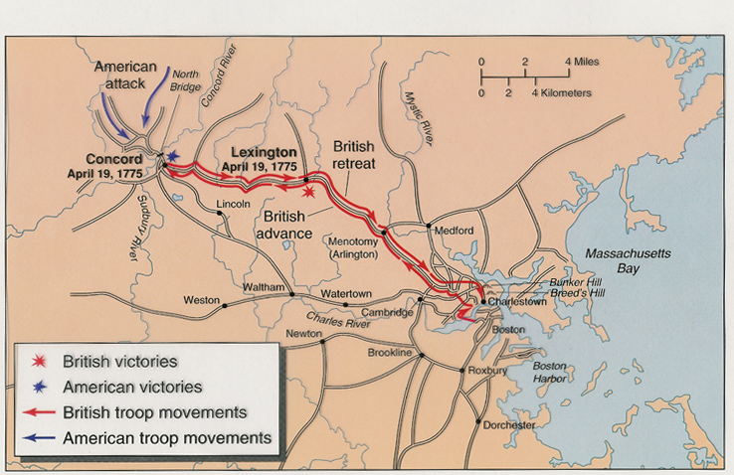
How: Marched to Concord but were stopped by the militia in Lexington.

